NYSA 8U RULE BOOK
Current as of September 21, 2023

SECTION 1 -- EQUIPMENT

  - All bats (alloy or composite) having the USSSA/BPF 1.15 Thumbprint stamp, the BBCOR stamp, or USA Baseball Stamp are acceptable. ALLOY bats may NOT contain the words "Coach Pitch" or "CP" or "Tee Ball (T-ball) written on them. Big Barrel bats are acceptable up to widths of 2 3/4". For the 8U Division, no bat length/weight combination may exceed "-10" or "Drop -10." The formula to determine the legality of the bat is as follows: length of bat minus the weight of the bat. For example, 28 Inches minus 18oz = Drop -10

1.1.1 PENALTY: The batter using an illegal bat shall be called out and all runners shall return to the bases occupied by them at the time such batter took his position in the batter's box. The use of the illegal bat must be protested prior to the first swing of the next batter.

1.2 Players may wear any type of clothing in local league play that is approved by NYSA. This clothing shall include shoes, but not shoes with metal cleats. Players should always be in uniform which includes hat, shirt, pants, and socks. Shirts should be tucked in and hats worn with bill facing the front.

1.3 Helmets must be worn by batters, base runners, on-deck batters, bat-boys. The batter's helmet shall be made of ultra-high impact plastic. The shell shall be of one-piece construction. The helmet shall have pieces for the ears and full protection for the head and temples. The padding shall be of heavy rubber or similar material. Helmets that are not designed to stay on without a chin strap must be worn with a chin strap.
1.3.1 NOTE: It is important that helmets stay on while players are sliding or running the bases.
1.3.2 PENALTY: For a first offense, the player shall be warned by the umpire; for the second and subsequent offenses in the same game, he shall be called out. If the violation is by a batboy or on-deck batter, the penalty for his second offense is removal from game and from field.

1.4 All other equipment that is used in the NYSA 8U program, such as gloves, hats, uniforms, shoes, and umpires’ equipment shall be the choice of NYSA. It is mandated that a catcher utilizes a cup, which is not provided by NYSA.

1.5 All pitchers must wear a pitcher’s face mask or batting helmet with a cage for protection. The league will provide facemask to be used by the players or the player can provide his/her own mask at his/her own cost.

SECTION 2 -- PLAYER AGE LIMIT AND VALIDATION

2.1 The 2023 Little League Age Chart will be used to determine a player’s age and eligibility. Anyone whose 6th, 7th, or 8th birthday (up to 8 years, 6 months) falls between September 1, 2014 and February 28, 2017 shall be eligible to compete and complete the current 8U season, as well as compete in tournament competition.

2.2 When using the Little League Age Chart, match the month to the year the child was born on and this will determine the child’s playing age. NYSA 8U does not allow kids under 6 years of age to play ball. The oldest a child may participate in 8U is 8 years and 11 months old.

2.3 The NYSA website is compatible with the Little League Age Chart, and the rules within this guide, to sort player signups appropriately.

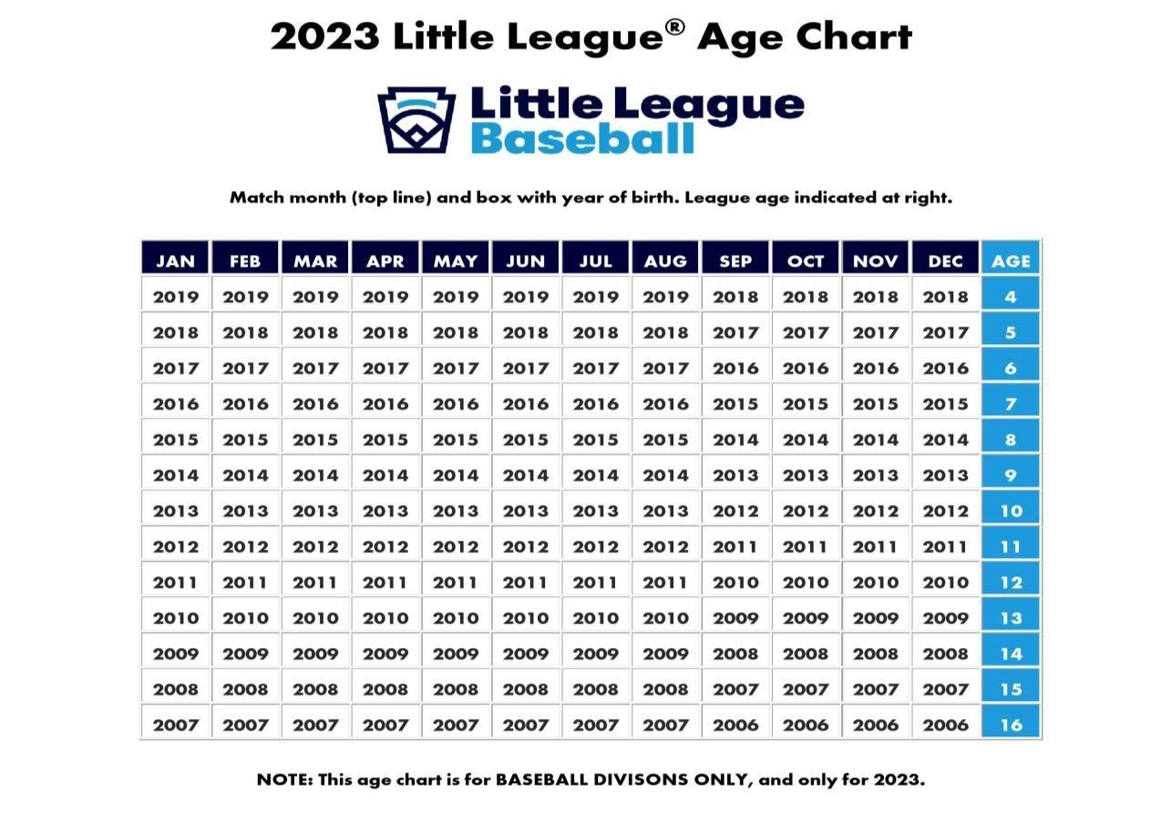

SECTION 3 -- SELECTION OF PLAYERS

3.1 At NYSA, each league shall determine its own method of selection of players to form a team roster. For 8U, a player tryout will be held with a coach’s draft to follow. Players will be evaluated for throwing, catching, and hitting by the designated head coaches. Following the evaluation, each coach will rack and stack the players appropriately in preparation of the draft. The player’s draft will be held at a time determined by the Commissioner. Additionally, the draft will be hosted and overseen by the Commissioner as well.

3.2 Those who do not register in time to participate in the 8U tryout and draft system shall be ineligible, with these exceptions – anyone who was sick or injured or anyone who became a new permanent resident of
the community after the selection. Those who were sick or injured shall have their disabilities
confirmed by a physician's note.

3.3 A new resident arriving after the selection may be assigned to a team provided all coaches of NYSA teams participating in the player pool and the NYSA Baseball Commissioner approve the assignment. Managers shall not drop a player from their rosters in order to sign a new player.

3.4 In the spirit of keeping the competition fair, each Head Coach is allowed to freeze three players before a draft. This allows a coach to protect or “freeze” their own son, their assistant coach’s son, or a child that wishes to play for a specific coach. The three-player freeze limit is strictly enforced. Any changes or waivers to this rule must be cleared by the NYSA Baseball Commissioner.

SECTION 4 -- GENERAL INFORMATION

4.1 In local league play, a continuous batting line-up for the entire team will be in effect. This means all
players, even if the team is larger than 10 players, will be included in the batting lineup.

4.2 Starting line-ups (defensive positions) shall consist of 10 players but no less than 8 players. With 10 players, 6 will play infield and 4 will play outfield. When only 9 players are accounted for, the team will omit an outfielder position or a pitcher’s position. When only 8 players are accounted for, the team will omit an outfielder and a pitcher’s position. A team failing to field at least 8 players within fifteen minutes after the scheduled game time shall forfeit the game. The score shall be entered in the record book as 6-0 in favor of the winning team. However, the game can still be played under the forfeit without keeping score.

4.3 Substitutions must be made at the beginning of each half inning.

4.4 In full 6 inning games, each player must play at least 2 full innings on defense and offense and bat at least once.

4.5 All batters must remain inside the dugout while waiting to bat except the on-deck batter who may wait in the on-deck circle.

4.6.1 PENALTY: Strike shall be called for each offense after the team has been warned once.

4.7 The infield fly rule is NOT in effect.

4.8 Bunting is not permitted. Chopping down on the ball, even though the batter swings through the ball, may be considered as an attempt to accomplish the same thing as a bunt. If the ball, however, reaches an infielder, the umpire has the discretion to rule it a non-bunt and let the play stand.

4.8.1 PENALTY: The batter is warned for first offense. A strike is called and runners return to bases
previously occupied. Subsequent offenses, the batter is out.

4.9 Base stealing is not permitted. A baserunner must be in contact with his base at the time the ball is hit by the batter. If the baserunner is caught leaving the base early, he will be called out.

4.10 Once a batted ball is in an infielder’s possession, the umpire will call “time,” and the baserunners shall not advance to another base. If the baserunner already departed to the next base prior to the infielder player gaining possession of the ball, he may continue to that base at his own risk, but he may not advance past that intended base. If there is an overthrow by a defensive player to the baserunner’s intended base, only then the baserunner may advance to the next base.

4.10.1 NOTE: Possession of the ball is defined as the ball is secured in hand or glove and the
defender has proven he has complete control of the ball.

4.11 If the ball is struck hard enough to roll past the ten-foot foul circle in front of home plate, it is a fair ball. If the ball is hit, lands in fair territory and rolls back across the foul circle, it is a foul ball. If the ball stops on the foul circle, it is a fair ball.

4.12 The batter shall receive a maximum of 5 pitches, excluding the 5th pitch if it is hit and becomes a
foul ball.

4.12.1 There are no intentional walks or bases on balls in 8U Baseball. If a batter is hit by the ball, it is called a “ball,” and the batter does not take first base.

4.12.2 If the batted ball makes contact with the pitching machine or the coach pitcher, a dead ball is called and the pitch is considered a no pitch. The batter will reattempt the at-bat with the same ball/strike count prior to the no pitch called. No runners shall advance on the dead ball and will return to their previous base.

4.13 Slinging the bat: For the first offense, the batter shall be given a warning, and the warning will be
recorded in the scorebook. For the second and subsequent offenses in the same game, the batter
shall be called out. A slung bat is the release of the bat in a dangerous fashion that is part of the
initial motion of the swing.

4.14 A team on defense shall be allowed no more than two time outs per inning. Exception - injury to a player or other emergency.

4.15 A team on offense shall have three (3) outs or score a maximum of 7 runs per inning, whichever comes first.

4.16 Should a player arrive late (no later than 15 minutes late), he/she may enter the batting order as
the last batter.

4.17 Once a game has progressed and a player is injured, ejected, ill, or removed from a game, the player’s batting position will reflect an automatic out when it is his turn to bat.

4.18 If an overthrow or missed catch occurs at first base, the runner may advance only to second base
and no further.

4.19 An official game is concluded once the maximum time limit of 1 hour and 15 minutes is reached or 6 innings completed. A game called because of rain, lightning, darkness, etc., shall be considered a regulation game after 3 complete innings of play. The home team must afford 3 innings to bat to give all players an opportunity to hit at least once and give the visiting team an opportunity for all substitute players to play the field at least once.

4.19.1 A game called for any reason before it is official shall be declared "no contest” and shall
be replayed in its entirety at a later date.

4.19.2 Games that result in a tie score after regulation will be ruled a draw.

4.20 The next inning may begin with any time remaining on the umpire’s clock. Once the inning has
started, it must be played until the inning is finalized, unless the home team is winning. If the
home team is ahead at the bottom half of the inning, the game is over. If there is time on the
clock and a team refuses to take the field because they are ahead, then the team refusing will be
penalized by forfeiting the game. If both coaches agree to conclude the game with time
remaining on the clock, then the game will officially end.

4.21 Players may shade to the left or to the right of their normal position; however, those positions
normally to the right of second base cannot move to the left of second base before the ball is hit,
and those positions normally to the left of second base cannot move to the right of second base
before the ball is hit.

4.22 Players, managers, or coaches may be removed from the game for unsportsmanlike conduct
after the team has been warned once. If at anytime unsportsmanlike conduct is performed
by multiple parties (to include fans, parents, coaches, or players), becomes egregious, or
extremely flagrant, the umpire has the right to declare the game a “no contest.” After doing so,
the scoreboard will be turned off, the scorebook is turned in, and the umpire will depart the field.
The game will not count as an official game, and it will not be made up at a later date.
Nevertheless, the teams are still provided the opportunity and encouraged to complete the game
amongst themselves so that recreational baseball is not taken away from the players.

4.23 Electronic or other means of communication with people outside the playing field for the
purpose of coaching or strategizing shall not be permitted.

4.24 The Home Team Coach is responsible for texting the Commissioner with the outcome of the game. The Commissioner will keep track of the results of each game and provide the standings for the league. Two points are awarded for a win. One point is awarded for a draw. Zero points are awarded for a loss.

SECTION 5 – PITCHER’S MOUND

5.1 The pitcher’s mound shall be in the center of the infield, 40-feet from tip of home plate.

5.2 A 6-foot pitching line will be drawn 40 feet from the point of home plate. The defensive player

pitcher will stand either on the right or left side of the coach on the line (he will not stand in front of

the coach or pitching machine) and must be within 6 feet of the Coach Pitcher.

5.2.1 NOTE: At least one foot of the Player Pitcher shall remain in contact with the 6-foot Pitchers line until the ball is released by the Coach Pitcher.

5.3 A 10-foot radius circle will be drawn around the center of the pitcher’s mound.

5.4 It is mandatory that the Player Pitcher wears a batting helmet with a cage or a facemask.

5.5 The pitching machine will be the primary means of pitching to a batter. If the pitching machine is not

operable, the Coach Pitcher shall throw pitches to the batter in an overhand fashion. The Coach

Pitcher can pitch from anywhere within the 10-foot circle but must maintain at least one foot inside

the pitching circle.

5.5 The Coach Pitcher must make every attempt to avoid interference with a ball in play. If in the
judgment of the umpire the Coach Pitcher interferes with a play in progress, the umpires will declare
a “Dead Ball” and will take such action as the Umpire deems appropriate to nullify the interference.

5.6 At no time shall any defensive player be stationed in front of the 6-foot pitching line before a pitch is
thrown. All defensive players shall remain behind the line until the ball is released by the Coach
Pitcher.

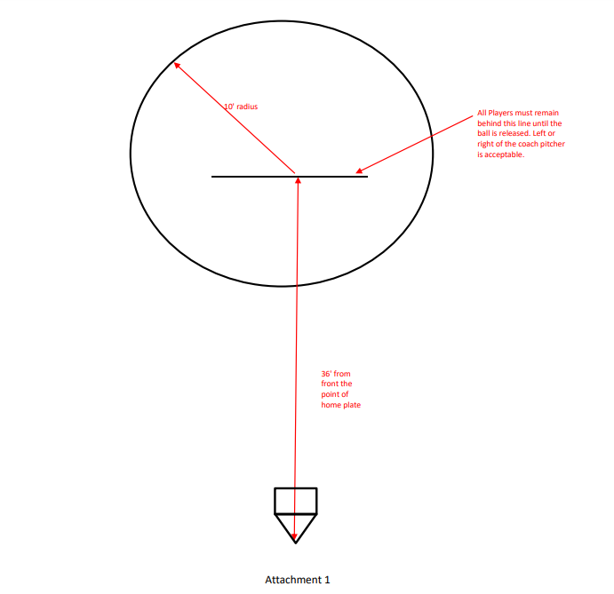
40’ From the point of home plate.

SECTION 6 – PROTESTS (FOR USE DURING SPRING BALL ONLY)

5.1 A protest which involves an umpire's judgment shall not be accepted.

5.2 Only the team manager or the acting team manager shall be entitled to file a protest.

5.3 The only legal protest shall be one which involves a violation of playing rules or the use of
an ineligible player.

5.4 The protesting manager on a play situation shall notify the umpire he is protesting before another swing by the batter. The umpire shall announce that the game is being played under protest, but failure of the umpire to make this announcement shall not affect the validity of
the protest.

5.5 A protest based on a play situation shall be considered only if it is placed in writing by team
manager and submitted to the Commissioner within 24 hours.

5.6 A protest on the grounds of the use or non-use of a player shall be filed with the Commissioner within 24 hours after the completion of the game. The decision as to whether the game, or games, shall be forfeited or replayed in the event the protest is upheld, shall be left to the discretion of the Commissioner.

APPROVED BY: //SIGNED//
BRANDON A. McSWAIN
NYSA BASEBALL COMMISSIONER
21 SEPTEMBER 2023

